Лабораторная работа 9

Системы обнаружения вторжений

Постановка задачи:

1. Спроектировать физическую сеть для заданного расположения узлов
2. Установка и настройка системы IDS (системы обнаружения вторжений) Snort.

Ход работы:

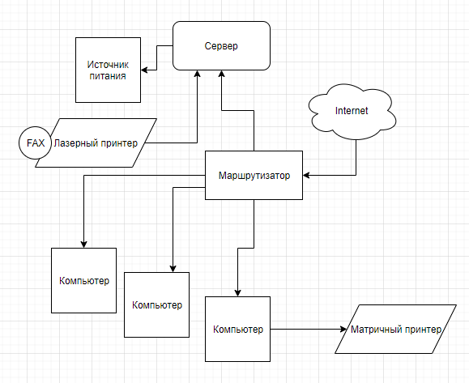

**Установка и настройка Snort**

Установка:

rpm –i snort-1.9.1-1snort.i386.rpm

Настройка:

Открыть файл: snort.conf.

1. Установка переменных сети

var HOME_NET 192.168.168.0/24

var EXTERNAL_NET !$HOME_NET

var DNS_SERVERS $HOME_NET

var SMTP_SERVERS $HOME_NET

var HTTP_SERVERS $HOME_NET

var SQL_SERVERS $HOME_NET

var TELNET_SERVERS $HOME_NET

var ORACLE_PORTS 1521

var HTTP_PORTS 80

var SHELLCODE_PORTS !80

var RULE_PATH /etc/snort

Подключить файлы содержащие классификацию обнаруженной атаки и ссылки на багтраки

include classification.config

include reference.config

2. Настройка механизма обнаружения атак

preprocessor frag2

preprocessor stream4: detect_scans, disable_evasion_alerts

preprocessor stream4_reassemble

preprocessor http_decode: 80 unicode iis_alt_unicode double_encode iis_flip_slash full_whitespace

preprocessor rpc_decode: 111 32771

preprocessor portscan: $HOME_NET 4 3 portscan.log

preprocessor portscan-ignorehosts: 192.168.168.0/24

preprocessor arpspoof

preprocessor conversation: allowed_ip_protocols all, timeout 60, max_conversations 32000

preprocessor portscan2: scanners_max 3200, targets_max 5000, target_limit 5, port_limit 20, timeout 60

include $RULE_PATH/bad-traffic.rules

include $RULE_PATH/exploit.rules

include $RULE_PATH/scan.rules

include $RULE_PATH/finger.rules

include $RULE_PATH/ftp.rules

include $RULE_PATH/dos.rules

include $RULE_PATH/ddos.rules

include $RULE_PATH/dns.rules

include $RULE_PATH/web-cgi.rules

include $RULE_PATH/web-iis.rules

include $RULE_PATH/web-client.rules

include $RULE_PATH/web-php.rules

include $RULE_PATH/sql.rules

include $RULE_PATH/icmp.rules

include $RULE_PATH/netbios.rules

include $RULE_PATH/misc.rules

include $RULE_PATH/attack-responses.rules

include $RULE_PATH/mysql.rules

include $RULE_PATH/pop3.rules

include $RULE_PATH/pop2.rules

include $RULE_PATH/other-ids.rules

include $RULE_PATH/web-attacks.rules

include $RULE_PATH/backdoor.rules

include $RULE_PATH/shellcode.rules